4.12: a)
b) With 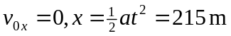.
c) With 

